Networking and Security Operations with SIEM, Forensics, and Traffic Analysis
Task 05 Report :
Name : Manish Tiruwa
Date : 15/03/2026
Environment : Kali Linux (Virtual Machine)

Introduction
This task focuses on networking and security operations, including subnet design, network traffic analysis, and security monitoring. The objective is to understand how networks are structured, how data flows between devices, and how potential security incidents can be detected and investigated.
In this task, subnetting is used to design a small office network, while tools like Wireshark are used to capture and analyze network traffic. Additionally, the ELK Stack is used as a SIEM solution to monitor logs and visualize security events. Incident simulation and threat hunting techniques are also performed to identify suspicious activities and indicators of compromise (IOCs).

Subnet Design
Subnet Design for Small Office Network :
A subnet was designed for a small office network containing approximately 20 devices, including workstations, printers, and one server.

IP Range Selected :
- Network Address : 192.168.1.0/27
- Subnet Mask : 255.255.255.224

Subnet Calculation :

Parameter | Value
Network Address | 192.168.1.0
Broadcast Address | 192.168.1.31
Total IP Addresses | 32
Usable IP Addresses | 30
Usable Range | 192.168.1.1 – 192.168.1.30

Device Assignment :

Device | IP Address
Router | 192.168.1.1
Server | 192.168.1.2
Printer 1 | 192.168.1.3
Printer 2 | 192.168.1.4
Workstations | 192.168.1.5 – 192.168.1.20

Reason for Selecting /27 :
A /27 subnet was selected because it provides 30 usable IP addresses, which is sufficient for a small office network with approximately 20 devices. This allows additional IP space for future expansion while keeping the network organized and reducing unnecessary broadcast traffic.

Network Diagram :

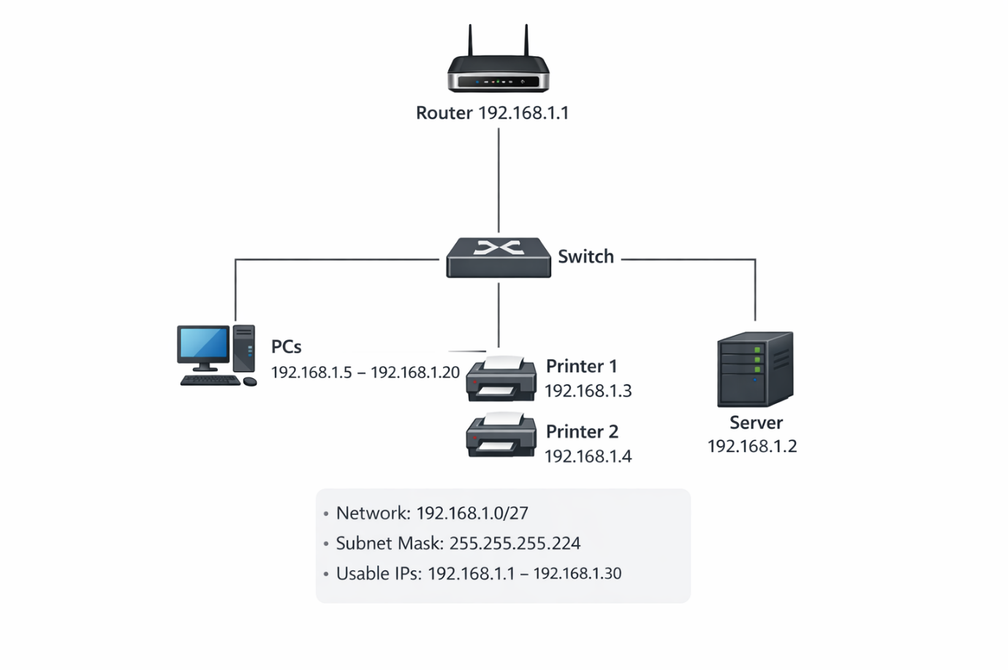
Figure 1: Small Office Network Topology

All devices operate within the 192.168.1.0/27 subnet, which provides a range of usable IP addresses from 192.168.1.1 to 192.168.1.30. The server is assigned the IP address 192.168.1.2, while printers and workstations receive addresses within the same subnet. This topology ensures efficient communication between devices and centralized network management

Network Traffic Analysis using Wireshark :
Network traffic was captured from the Kali Linux virtual machine and analyzed using Wireshark. The capture contained normal browsing and background operating system traffic, including DNS lookups, HTTP requests, TLS sessions, QUIC traffic, and ICMP packets. The objective was to identify major protocols in use, determine the top communicating hosts, and observe any unusual traffic behavior.

Protocols Observed :
The protocol hierarchy statistics showed that most traffic was based on IPv4. Both TCP and UDP were actively used during the capture. QUIC accounted for a significant portion of the transferred bytes, while TLS traffic was also clearly visible, indicating encrypted communication. DNS traffic was present for domain resolution, and HTTP traffic was observed in a small number of packets, including a successful HTTP/1.1 200 OK response. OCSP traffic was also seen, which is typically used for certificate validation.

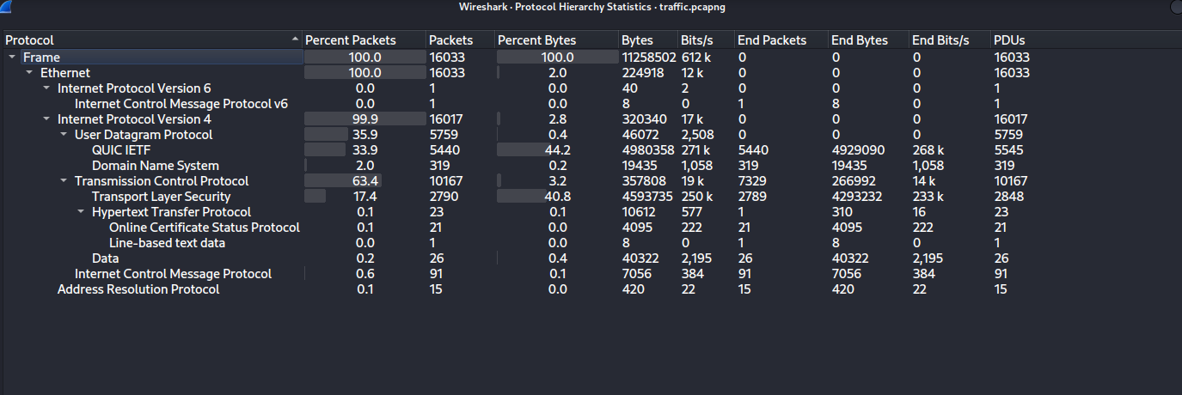
Figure 2: Protocol Hierarchy Statistics from Wireshark

The protocol hierarchy statistics showed that IPv4 traffic dominated the capture, with both TCP and UDP actively used. QUIC and TLS contributed a large share of the traffic volume, while DNS and HTTP were also observed

Top Talkers :
Using the Wireshark Conversations view, the most active communicating hosts were identified from the local system 192.168.1.6. The most significant connections included :
- 142.250.183.174 with approximately 4,946 packets and 3 MB
- 142.251.43.46 with approximately 3,393 packets and 4 MB
- 185.199.108.154 with approximately 2,177 packets and 2 MB
- 142.251.157.119 with approximately 1,246 packets and 1 MB

These hosts represented the main external communication partners during the capture period and accounted for the highest traffic volume.

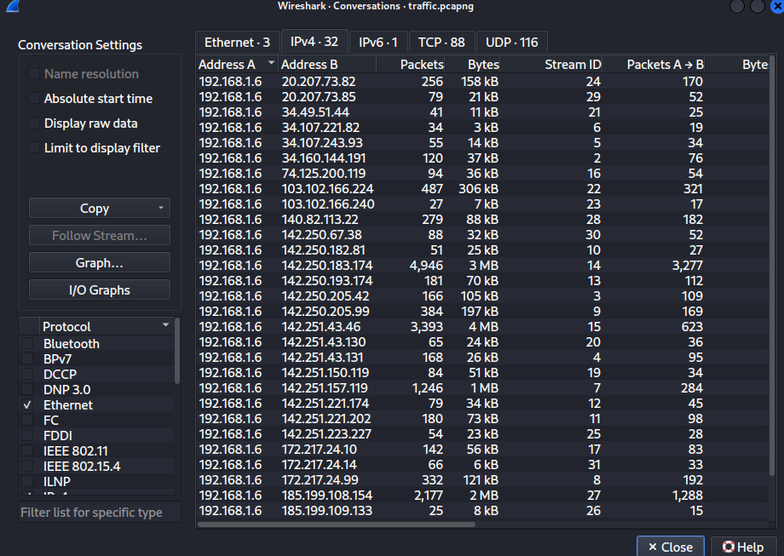
Figure 3: Top Talkers Identified in Wireshark Conversations

The Conversations view in Wireshark was used to identify the most active communication pairs and the hosts generating the highest amount of traffic.

DNS Analysis :
DNS analysis showed repeated queries from 192.168.1.6 to the DNS server 192.168.1.1 Several queries were related to wpad and wpad.domain.name and many of these returned No such name responses. Additional DNS requests were seen for Mozilla and YouTube-related domains. The repeated WPAD lookups are a common system behavior in some environments, but they may also appear unusual during analysis because of their frequency and repeated negative responses.

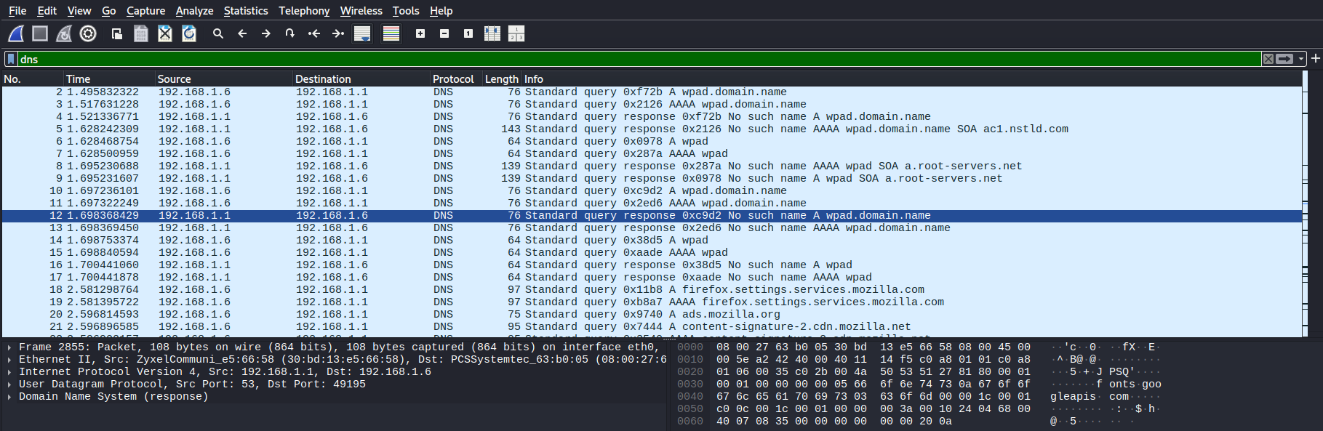
Figure 4: DNS Traffic Showing WPAD Queries and Responses

DNS traffic analysis revealed repeated WPAD-related queries and several negative responses such as “No such name,” which were useful for identifying name resolution behavior.

HTTP and TLS Analysis :
HTTP traffic analysis showed a successful GET request followed by an HTTP/1.1 200 OK response. This indicated normal web communication between the local host and an external server during the capture period.

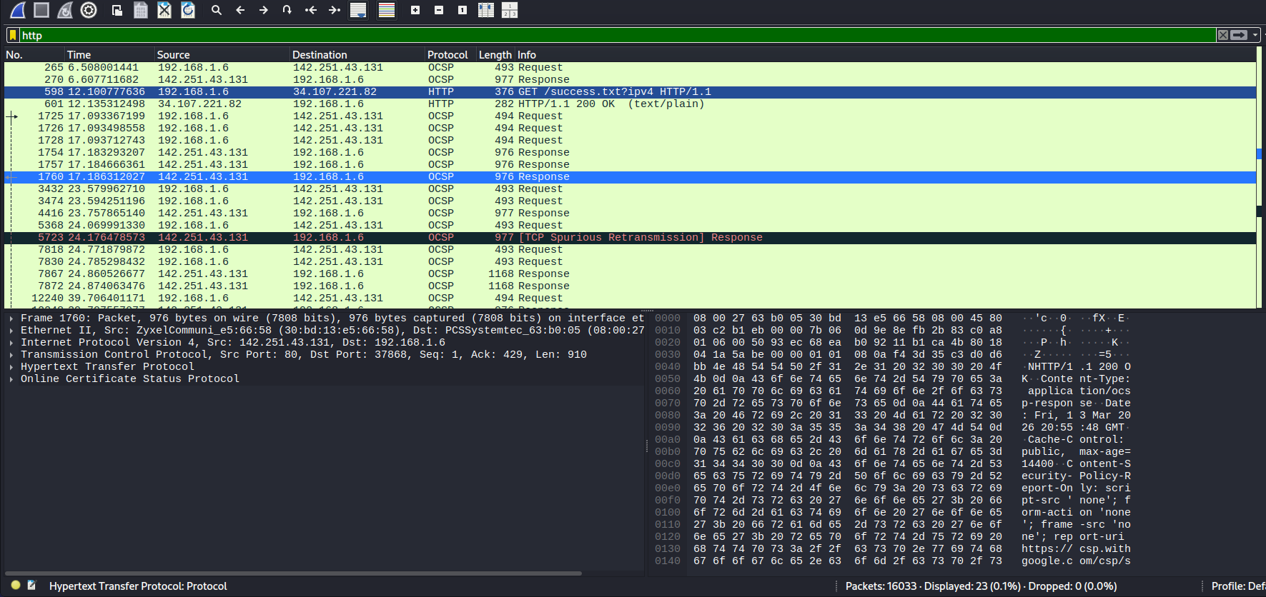
Figure 5: HTTP Traffic Showing Successful GET Request

HTTP analysis showed a successful GET request followed by an HTTP 200 OK response, confirming normal web communication in the capture.

TLS Traffic :
TLS traffic was also observed in the capture, including Client Hello and Server Hello packets. This confirmed that the host was establishing encrypted sessions with external services, which is expected in normal secure web browsing activity.

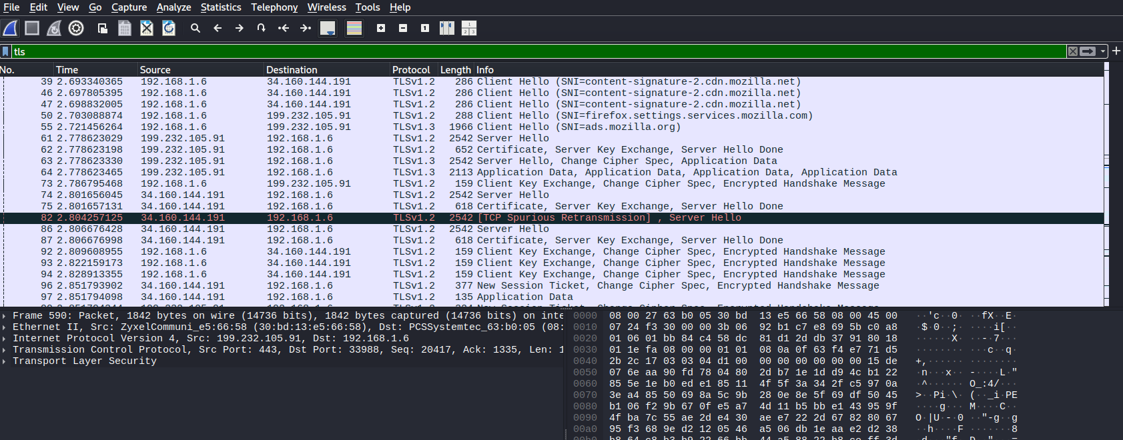
Figure 6: TLS Handshake Traffic in Wireshark

TLS traffic contained normal encrypted session setup behavior, including Client Hello and Server Hello packets.

TCP figure :
TCP traffic analysis revealed normal session communication between the local host and multiple external servers. During inspection, some packets were marked as TCP Dup ACK and TCP Spurious Retransmission. These patterns can occur because of temporary delay, packet reordering, or minor packet loss, and they are useful indicators during network troubleshooting.
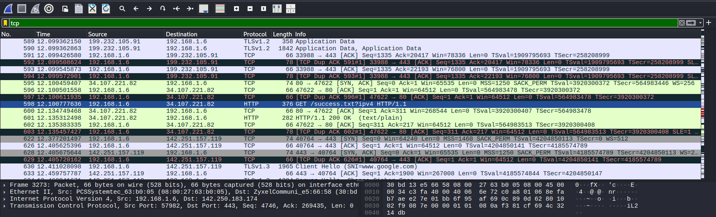
Figure 7: TCP Traffic Showing Duplicate ACK and Retransmission Behavior

Final Wireshark Analysis :
Network traffic from the Kali Linux virtual machine was captured and analyzed using Wireshark to study communication patterns and identify key protocols. The capture showed that most traffic was based on IPv4, with TCP and UDP being the main transport protocols. QUIC and TLS were also observed in significant amounts, indicating encrypted communication, while DNS and HTTP traffic confirmed normal hostname resolution and web activity. The Conversations view helped identify the top talkers, where the local host 192.168.1.6 communicated most frequently with several external IP addresses.
During deeper analysis, repeated DNS queries for wpad and wpad.domain.name were seen, many of which returned No such name responses. HTTP analysis showed a successful GET request followed by an HTTP/1.1 200 OK response, while TLS packets such as Client Hello and Server Hello confirmed secure session establishment. TCP analysis also showed TCP Dup ACK and TCP Spurious Retransmission packets, which suggested minor network delay or packet reordering. Overall, the Wireshark capture demonstrated normal network activity along with a few unusual but non-malicious patterns that were useful for troubleshooting and traffic analysis.
SIEM Setup :
The ELK Stack was configured on a Kali Linux virtual machine to perform basic SIEM operations and centralized log monitoring. Elasticsearch and Kibana were installed and started successfully. Due to limited system resources in the virtual environment, Logstash was disabled to reduce memory consumption and improve overall system stability. After the setup, Kibana was accessed through the local web interface on port 5601.
To verify that the SIEM environment was functioning correctly, a test index named test-logs was opened in Kibana Discover. The indexed log entries contained structured fields such as @timestamp, host, level, and message, which confirmed that logs were successfully ingested and searchable.
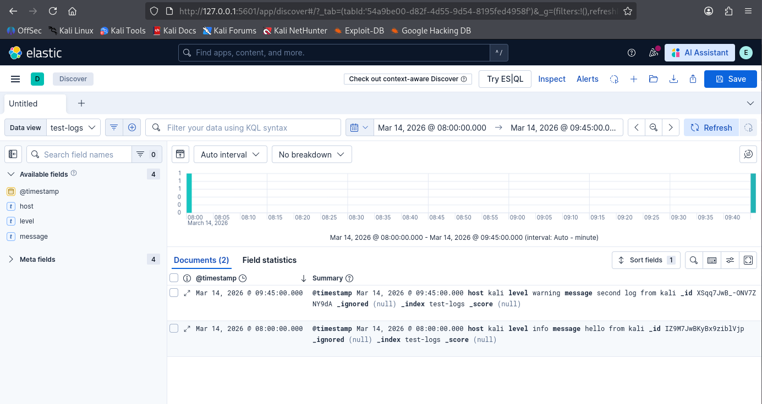
Figure 10: Kibana Discover Showing Indexed Logs

Further inspection was performed by expanding an individual log record. This allowed detailed field-level analysis of the selected event, including the host name, log level, timestamp, and message content.

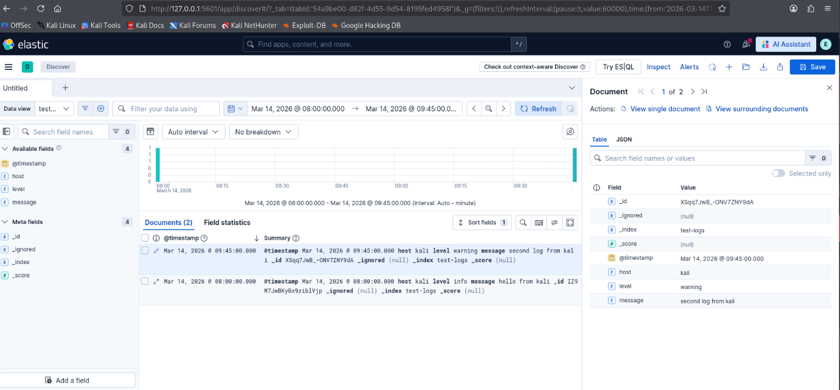
Figure 11: Expanded Log Record in Kibana

The Field Statistics view was also reviewed to analyze the indexed fields and their values. This confirmed that the test logs were structured correctly and could be used for basic event analysis and monitoring activities.

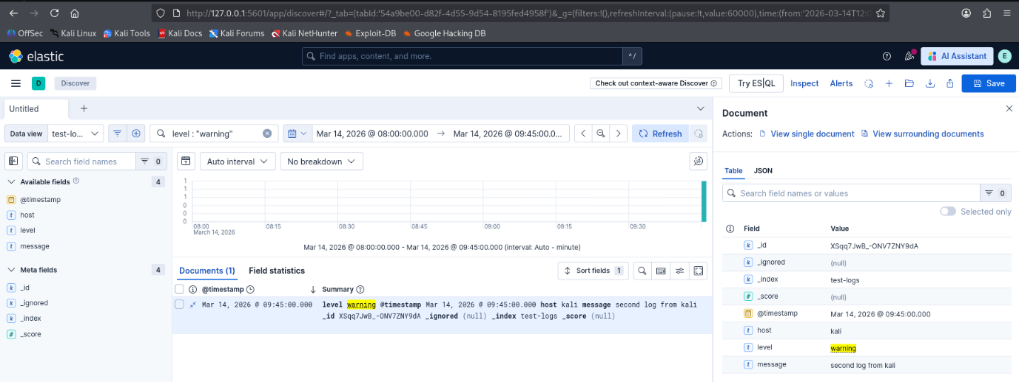
Figure 12: Warning-Level Event Filtered in Kibana.

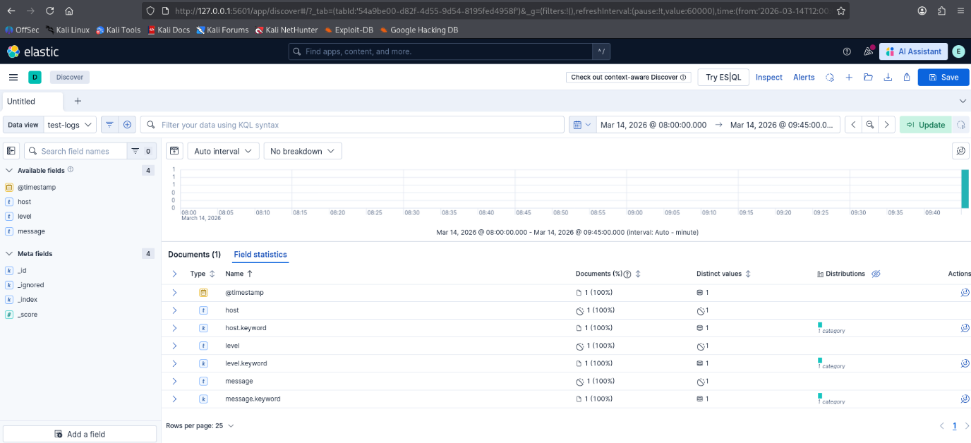
Figure 13: Field Statistics in Kibana Discover.

Incident Forensics :
A basic incident investigation was simulated using the indexed log data in Kibana. The focus of the investigation was a warning-level event generated from the host kali. The event was identified in Kibana Discover and then examined in detail through the expanded document view. Key attributes such as timestamp, host, severity level, and message content were reviewed to understand the event context.
The suspicious event was visible as a warning log entry with the message second log from kali. Although this was a controlled test event rather than a confirmed real attack, it was useful for demonstrating the incident investigation workflow in a SIEM platform. The process involved identifying the event, filtering it from other records, and reviewing the structured log fields to build a simple timeline.
The investigation showed how even small datasets can be used to simulate incident triage and log-based forensics. In a real production environment, the same workflow could be extended to correlate warning events with network captures, authentication logs, or host-based telemetry.

Threat Hunting :
A basic threat hunting exercise was conducted using Kibana Discover and Kibana Query Language. The log dataset was searched to identify potentially important events by filtering on the level field. When the filter level : "warning" was applied, the warning event from the kali host was isolated successfully. This demonstrated how centralized logs can be queried to find events that may require further review.
Field-level inspection and field statistics were also used to understand the structure of the ingested data. The fields @timestamp, host, level, and message were analyzed to determine what indicators were available for searching and filtering. This activity showed how Kibana can support basic threat hunting by allowing analysts to focus on specific event types, hosts, or log severities.
Although no confirmed compromise was identified in this dataset, the exercise demonstrated the fundamental process of hunting for indicators of concern in SIEM data. It also highlighted the importance of structured logging and searchable fields for security analysis.

Challenges Faced During SIEM Setup :
The ELK Stack setup was one of the most challenging parts of this task because my laptop has only 8 GB RAM, and running Elasticsearch, Kibana, and Logstash inside a Kali Linux virtual machine caused performance and stability issues. During installation and service management, errors such as “Unit elasticsearch.service could not be found,” “Unit logstash.service could not be found,” and “Unit kibana.service could not be found” were encountered, which required repeated troubleshooting, reinstallation attempts, and service verification. I had to install the ELK Stack 2 times, and in between I also deleted and reinstalled Kali Linux, which consumed a significant amount of time and caused a delay in completing the task before the submission deadline.
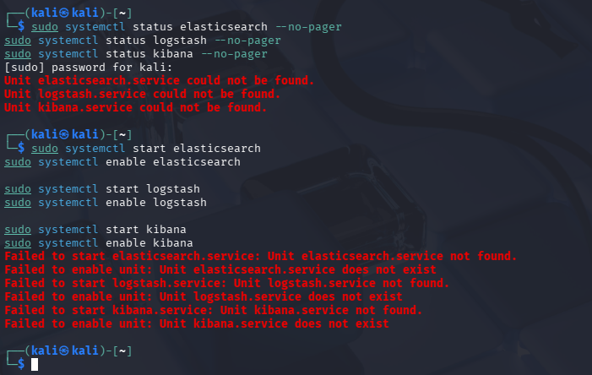
Figure 14: Service Errors Encountered During ELK Stack Installation.
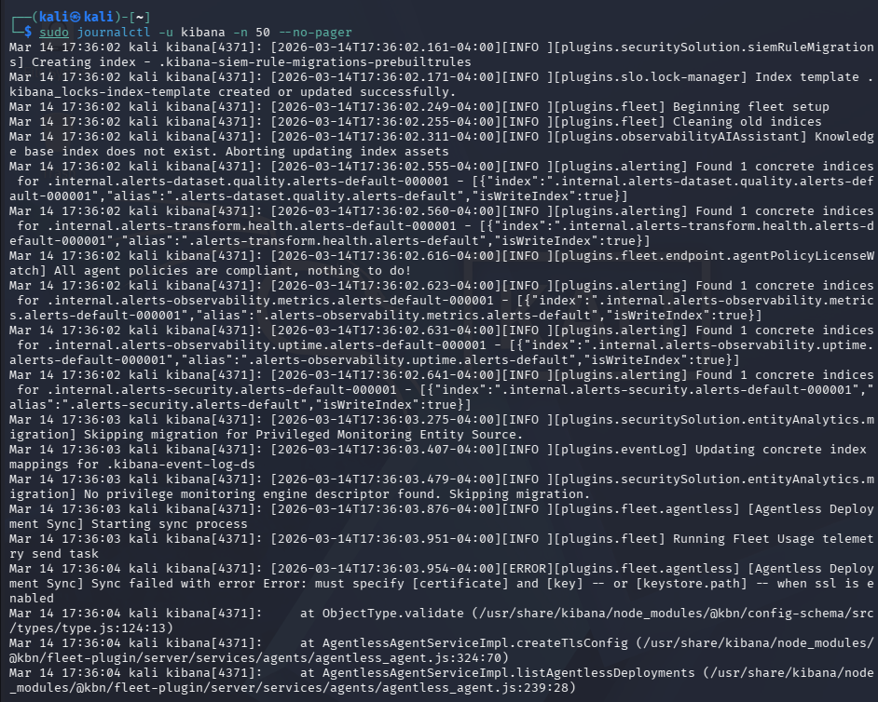
Figure 15: Kibana Log Output During Troubleshooting

Key Learnings
This task helped me understand how subnetting, packet analysis, protocol troubleshooting, and SIEM-based log monitoring work together in practical security operations. I learned how to use Wireshark and Kibana to inspect traffic, identify protocol behavior, filter events, and perform basic investigation and threat hunting activities. The biggest challenge was running ELK Stack on an 8 GB RAM laptop and recovering from multiple installation issues, but by reinstalling components, troubleshooting service errors, and optimizing the setup, I was able to complete the required analysis.

